

**574060-EPP-1-2016-KZ-EPPKA2-CBHE-SP**

**ENHANCEMENT OF HIGHER EDUCATION AND CORPORATE SECTORS INTEGRATION IN ACCORDANCE WITH NEW SOCIAL ENVIRONMENT -ENINEDU**

Report on the general overview of EU experience in business-HEI cooperation and its implementation into study process.

On December 26, 2017, the round table "International experience of university and business cooperation" was held at the Samara State University of Economics. It was organized by the International Cooperation Office in cooperation with the Office of Special Projects, Personnel Reserve, Employment and Entrepreneurship of Students, within the framework of the international project **Enhancement of Higher Education and Corporate Sectors Integration in Accordance with the New Social Environment (ENINEDU)**. The aim of the project is to study the experience of interaction and integration of higher education and the corporate sector in new social environment.

Lecturers and professors of the Samara State University of Economics visited partner universities: the University of Sopron (Sopron, Hungary), the University of Santiago de Compostela (Santiago de Compostela, Spain), the University of Nice Sophia Antipolis (Nice, France) .

Within the framework of the roundtable, representatives of the university shared their views, studied the European experience and impressions about the best practices of interaction between European universities and business partners.

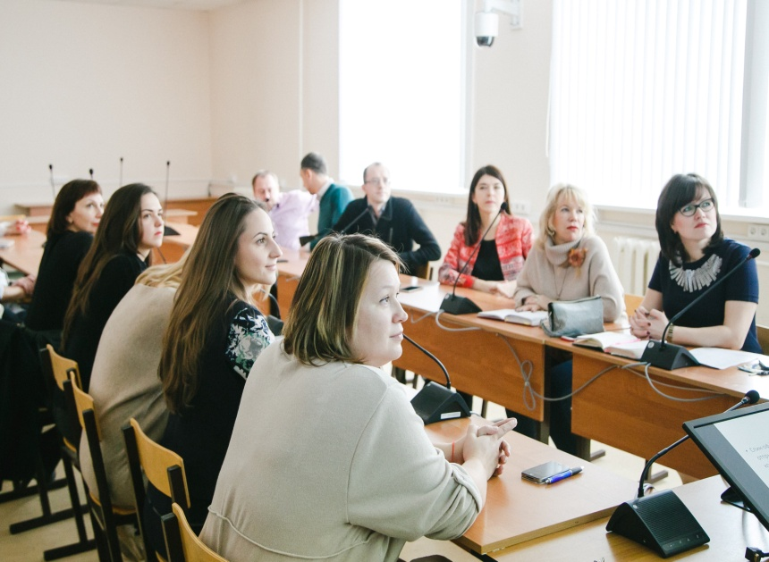

**1. Experience of business cooperation with the university of Sopron, Hungary from 13.11.2017 to 15.11.2017**

***Methods of interaction of business with the university.***

As a result of peer-to-peer learning held inthe University of Sopron,Hungary from 13.11.2017 to 15.11.2017 the following areas of business interaction with the university can be distinguished:

a) participation in the university's educational programs;

b) scientific research and projects;

c) advertising and promotion.

***Participation in the university's******educational programs.***

The University of Sopron pays serious attention to business cooperation and engages commercial companies to participate in educational programs in various formats. These include:

**- The use of commercial organizations and companies as bases of student practice during their educational process**. The practice for bachelor students is compulsory, conducted within 12-16 weeks after the 6 semester of training. All companies that act as practice bases are obliged to conclude appropriate agreements with the University of Sopron and must be included in the relevant university register which is annually approved by the Higher Education Department of the Ministry of Human Resources Management of Hungary;

**- Participation of business companies in the implementation of the dual education program.** The Hungarian dual education program involves a combination of theoretical training of students and their practical work in the company. The program of training includes 26 weeks of theoretical training and 22-24 weeks of practical work every year. The scheme is the following: first 13 weeks students who have chosen dual program take theoretical training in conjunction with students of the traditional system. Then there are 6 weeks of the examination session, during which students go to work for a full-time partner company, 40 hours a week. Preparation for the exam is done outside of working hours. On the day of the exam, students are released from work. After successfully passing the session, students continue to work for 4-6 weeks in the company without a vacation. This system is repeated six semesters of training.

During the whole semester, students receive a salary, including salary for 13 weeks of their attending classes at the university. The dual training system is supported by the state and is mandatory for implementation in Hungarian universities. Companies receive a tax deduction in the amount of wages paid to students. In addition, companies have the opportunity to participate in the training of the necessary specialist, who at the end of the training period can continue his career in this organization. Students receive experience, wages and the opportunity to get a job immediately after the end of the educational program.

In dual training, the topic of diploma thesis must be related to the company's activities. In conventional training such relation is not necessary and the topic of thesis may be theoretical.

Such dual education program has been conducted for several years in the forestry department. The economic faculty of the University of Sopron has just begun to implement this type of training at the year of 2017;

- **Involvement of companies as sponsors**, paying for the education of individual students (scholarship), allocating funds for replenishment of the faculty's fund, providing free of charge various materials for the university, paying for the content of the university's audiences and their filling with the necessary infrastructure, acting as strategic partners of the faculty;

**- Holding an Employer Week every semester**. Within this Week, commercial companies organize lectures, conduct workshops, develop case studies based on their business experience. Companies use this opportunity for their own advertising and selection of promising students as future employees. All classes within the framework of the Week are compulsory and are included in the training course for students. In addition, each semester there are outreach classes at the employer's sites. On average, each semester, about 350 students attend field trips in partner companies of the university;

**- Attraction of industry experts, managers and employees of the company to participate in the work of the faculty.** Representatives of business are involved in conducting courses of disciplines or individual classes, consultations during the implementation of research projects, participation in conferences and scientific seminars held at the faculty, work in the commission on the state examination and the presentation of diploma thesis. Business representatives can take part in the educational process as mentors for students interested in them. This format of cooperation is used by companies as a method of attracting future specialists and selecting prospective candidates for employment;

**- Training of the personnel of the organizations within the framework of additional educational programs.** In addition to standard programs, the faculty offers partial education programs, during which students can choose the necessary subjects and pay only for them. There are shortened courses lasting 2-4 semesters, without obtaining a diploma. There is a program "summer university", in which classes are held during holidays when the main groups of students are in their summer vacation.

The university has the experience of conducting courses of advanced training and retraining of specialists of companies in the field of forestry, furniture production, energy efficiency, etc.

**- Conducting joint analytical meetings, meetings, symposia.** Involvement of leaders and experts of organizations to participate in club meetings held at the university. Exchange of experience, discussion of new achievements in the field of professional knowledge, creation of new partnerships. The university provides its services as an organizer of business events, acting as a coworking center. At carrying out of actions by high school the full complex of necessary services is given, including the organization of catering service;

**- Participation in the state support program for start-up projects.** The University conducts trainings for students wishing to participate in the state support program for start-up projects, in which young entrepreneurs are allocated up to 10,000 euros for the implementation of the approved project. The training is paid by the state as a part of the state support program for start-up projects. The university helps students to draw up a business plan, with the approval of which the state allocates funds for the implementation of the project.

- **Participation of business companies in the current educational process.** Commercial organizations during the educational process take part in the development of concrete case studies on the basis of real situations and problems of enterprises. These case studies are studied by students as a part of workshops carried at the appropriate disciplines within the academic year. Also they are used as a practical task during some student competitions which are held in the university every semester. Commercial organizations can be involved to participate in adjustment and development of the undergraduate and graduate programs of the Sopron University.

Much attention is given to maintaining links with university graduators of former business cooperation partners. The availability of feedback on the quality of the students' preparation, the quality of the courses, the necessary of some additional knowledge and competencies has great importance for the development of the university.

Companies support the educational process by providing university laboratories with free of charge materials, semi-finished products and parts for scientific research and practical exercises carried out in the laboratories of the university.

The university has several classrooms that have been renovated and are equipped with sponsorship companies and the audiences are named according to the names of these companies.

***Research.***

**- Conducting researches ordered by commercial companies.** Commercial organizations can order researches on their areas of interest. There are several options of paying for ordered research, which differ by the degree of freedom of the institution at the disposal of the funds received. In the most stringent formats, the customer directly spells out the cost estimate, in the softest formats - he gives the university full opportunity to compile a budget for expenditures. In the vast majority of cases, 25% of the funds received from research orders are transferred to the Higher Education Department of the Ministry of Human Resources Management of Hungary.

The faculty carries out research by his own professors and other staff. Sometimes students are involved in research which is very good practice for them. The university often invites outside experts who are usually professors of some other universities or leading experts in the field of research. In rare cases, some of the work can be outsourced to third parties.

There are tax incentives in Hungary for companies in the performance of scientific work by the university and attracting students to participate in them;

**- Certification.** The university participates in certification programs for products of various companies. The greatest success in this direction is demonstrated by the Faculty of Forestry.

In particular, the university carried out testing and certification of materials (for example, composite materials), products (eg furniture, solar panels), operating conditions of companies.

The university does not currently carry out certification of employees for commercial companies.

The University's laboratories are used in the implementation of research and certification, in particular the laboratory of composites, the polymer laboratory, the energy laboratory, etc.

The equipment of the laboratories was purchased mainly in the framework of various grants provided to the university by both the European Union and the Hungarian government through special programs and projects.

***Advertising.***

The University uses all communication channels to attract students and business partners, including TV advertising, promotion on the Internet and joint advertising projects.

Within the framework of cooperation with the local railway company Gysev, a special daily route was designated named after the University of Sopron. This train has special design with the symbols of the university and serves as a free advertisement.

Great importance in interaction with business structures has the maintenance of good relations with graduates of the university. The University maintains a register of all companies with which it had some cooperation in the past. This register includes bases of practice, sponsors, customers for research and companies which are run by University graduates. The presence of good relations with managers and experts of local companies is considered at the university as an obligatory and extremely important direction for the development of an educational institution.

Companies regularly conduct various events at the university (for example, open house days of the company), within which they can present their companies as potential places for practical training by students and future employment of students.

Companies can sponsor individual projects and events held by the university and make charitable contributions to special funds created by the faculty of the university.

***Examples of cooperation of the university with business companies.***

The University of Sopron has a rich history of cooperation with business companies. Ikea, Tesco, General Motors, Knauf, Velux, Gysev, as well as a significant number of local companies, are acting as strategic partners of the university, practice bases or customers for research.

By order of the railway company Gysev, the Faculty of Economics conducted a study of the passenger transportation system aimed at calculating the expediency of increasing the number of stops for the express train from Budapest passing through Sopron.

The Forest Faculty held a week workshop with the involvement of students and teachers to develop a product line of the local furniture company.

The Faculty of Economics actively cooperates with such companies as Palatinus (hotel chain), Huncargo, Autoliv, Falco, IKEA, etc.

**Legislation of the country regarding cooperation of universities with business.**

The cooperation of universities with business is a necessary and directly demanded by the state. The state forms no more than 40% of the university budget, the remaining 60% of the university must earn independently, either by developing cooperation with business companies, or by receiving a grant. The income received from paid students can not form this part of the budget.

In the Hungarian system of higher education there is quite a noticeable autonomy. It can be seen not only at the university level, but also at the faculty level, where there are own funds, which the educational institution can dispose of almost independently. In the universities there is a system of financial managers (chancellors), which monitor the formation of budgets and ensure the transfer of 25% of revenues to the Higher Education Department of the Ministry of Human Resources Management of Hungary for subsequent redistribution.

At the state level, there are dual education programs, the implementation of which is compulsory for universities. There is a state standard in practice.

The state established tax deductions for companies that interact with educational institutions. Deductions apply to the costs of providing the wages of students enrolled in the dual system, to the costs of sponsorship projects and the payment of scholarships to university students.

**Additional results of the internship (not specified in the project memo).**

The University of Sopron is interested in exchanging students and implementing joint training programs.

There are programs of double diplomas for both bachelors and masters. The program can be implemented on the basis of a bilateral agreement between universities and does not require any contract signing at the ministerial level. The program provides for training during 2 semesters at the host university. An obligatory condition for the launch of the program is the coincidence of educational programs by at least 70%.

The university is implementing a dual-degree program at the PhD level, but at present it is irrelevant for Russian universities.

The university has a joint PhD program, which is being taught in 5 universities in 4 countries: Hungary, Austria, Slovakia and Croatia. Each country holds 1 semester of training. Based on the results of the training, student can choose any of the 5 universities to defend the thesis. The total duration of the program is 4 years. The first 2 years - training with the passing of exams, the second 2 years - preparation for the defense of the thesis work. The cost of the program is 1600 euros per semester.

Since 2013, for foreign students, the Hungarian scholarship program operates, which pays for tuition, accommodation and medical insurance for incoming students. In addition, there is a small monthly scholarship of 130 euros. For comparison, the average salary in Hungary is 500-600 euros.

In Hungary, as part of income taxation, individuals are entitled to transfer a certain part of the tax (1%) to different target needs (for example, for education, science, animal protection), and such payments can also go to the support fund of the faculty of the university.

**2. Experience of business cooperation with University of Santiago de Compostela from 27.11.2017-29.11.2017.**

University of Santiago de Compostela (Universidade de Santiago de Compostela, USC) is a university in the city of Santiago de Compostela, Spain.

The number of students studying in pre-university and post-college education, as well as teachers and university employees is estimated at about 40,000 people. In addition to Santiago de Compostela, the university has a branch (campus) in Lugo.

According to the number of students, the university is constantly included in the TOP15 in Spain. This is one of the oldest universities in Europe, operating nowadays. The University of Santiago was formed on September 4, 1495 as the grammar school of Lope Gomez de Marsoa.

 The university trains 27,000 students, employs about 3,000 scientists who have published more than 1,700 articles.

Scientific activity (including research and innovation) is financed by the research fund, amounting to 61 million euros. To a greater extent, it was formed by the state (40 million euros (66%)), as well as by sponsors (12 million euros) and 8 million by other contractors.

These investments give the state income in the form of 100 thousand euros of additional taxes, as well as increased knowledge, training and social benefits. (Fig. 1)

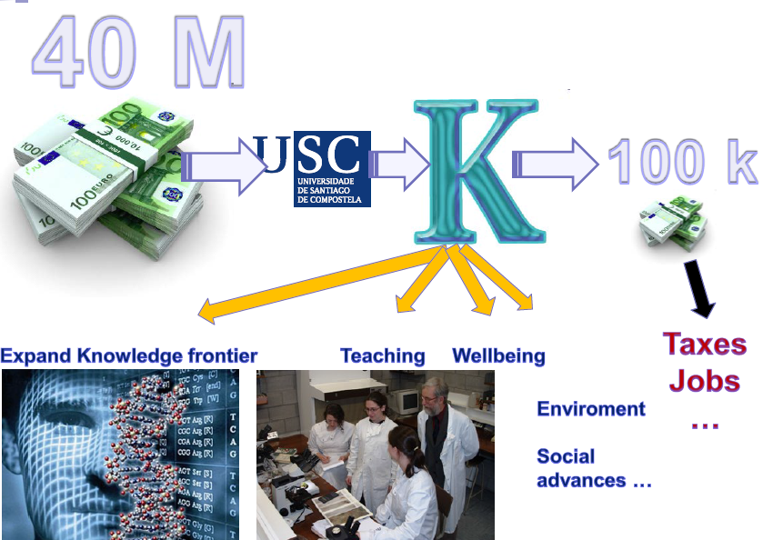

The administrative structure of the university includes a zone for the transfer of technology and entrepreneurship. It is headed by the pro-rector on these issues.

Management consists of two main sectors. Business incubator (in which the spin-off companies are located physically), as well as a network of research and development infrastructure (laboratories, etc.)

In 2015, the University of Santiago de Compostela performed 59 applications for a patent, almost four dozen transactions were concluded and one spin-off company was allocated.

The main goal of this direction of the university is the transfer of knowledge (Knowledge Transfer) and Entrepreneurship is presented as a way to achieve the objectives of knowledge transfer.

The first office for the transfer of technology was established at the university in 1989. Under the name SITT. Its main vectors of development were the creation of a database of scientific research and obtaining funding for their development, as well as the settlement of intellectual property issues.

Activities on scientific research and technology transfer are supported by a number of funds. One of the most successful projects is the society of the companies of the fund UNIRISCO. Venture capital of the company is formed at the University of Santiago.49% of the capital is the investment of companies. This fund has been functioning since 2006. Its main scientific interests are agro-food, biotechnology, health, new materials and IT.

With the support of the UNIRISCO Foundation and the USC, Innolact's project (for developing and creating a new cream cheese product, Quescrem) was implemented. The project started in 2009, and already in 2011 the sales level reached 3 million euros. Cream cheese represents original development and a unique recipe of the company, obtained as a result of spin-off activities of Innolact. Despite the successfully implemented technology transfer, Quescrem is still in constant cooperation with the dairy of Lugo (CTLácteo) and CDTI (Center for the Development of Industrial Technologies).

The USC business incubator provides training for residents and bringing the technology to the finished product. Almost half of the resident companies are located in the city council building.

The USC has a separate building for entrepreneurship and evaluation of research results called EMPRENDIA building.

Resident companies rent their offices there and conduct research. The equipment is in general use, resulting in savings in capital costs.

One of the spin-offs working in EMPRENDIA building is the Argos project. It is organized as the franchise of the Massachusetts Institute of Technology. Since 2013 the project Argos has implemented 24, the business plan, training and trainings passed more than 120 students, created one spin-off company.

The main activities of the Argos project are:

• -Testing a business idea

• -Time Building

• -Creation of an informed business plan;

The project employs 10 people, 4 of whom are scientists and researchers.

There are about 30 companies in EMPRENDIA building. One of the representatives of IT is CITUM. It is also implemented with the support of the UNIRISCO Foundation. The company is engaged in research on creating an application for orientation in buildings. The technology is similar to Google maps, only indoors. For example, shopping centers, hospitals, etc.

At the University of Santiago de Compostela, AYeconomics, an economic research center, is engaged in research into new markets and the demand for products. One of the research areas is the markets of Central Asia. Not only scientists, but also bachelor's and master's students are involved in research.

**3. Experience of business cooperation with University Nice - Sophia Antipolis from 6.12.2017-8.12.2017.**

3.1. Methodes of business interaction with the university.

Based on the study of the experience of the University of Nice - Sophia Antipolis, the following areas of business interaction with the university can be distinguished:

a) participation in the university's educational programs;

b) scientific research and projects.

**Participation in educational programs.**

University of Nice-Sophia Antipolis attracts commercial companies to participate in educational programs in various formats. These include:

- The use of commercial organizations and companies as the place for student internship. The internship for bachelor students is optional, compulsory internship is for master's students. In 2010, French law established a maximum period of internship - 6 months. All companies acting as internship places conclude corresponding contracts with the University of Nice-Sophia Antipolis;

Here is the example of the study plan for the master program with rather close inclusion of employer into the study process (Fig. 2)

**- Participation of business companies in the implementation of the alternate training program.**

Applicants must apply CV to the company and half of the time the students spend in the company. The university concludes a tripartite agreement: student-company-university. Each student has 2 tutors - a university professor and a company representative. At the University of Nice Sophia Antipolis there is a special unit (4 people), which deals with the "sale" of students to organizations. At the moment of peer-to-peer learning 1,000 university students were undergoing such a training program;

- **Attraction of industry experts, managers and employees of the company to participate in the work of the faculty**. Representatives of business are involved in three formats: professionals working in the company and providing free consulting assistance to individual students; temporary teacher (paid work at the university); an affiliated employee of the university (partially engaged in teaching, but the main time is in the company);



Figure 2. Study plan for the program "Engineers for Smart Cities"

- **Participation in programs supporting start-up projects, project work of students for specific tasks of the organization**. The University conducts a number of competitions: Challenge Jeunes Pousses - competition for the implementation of innovative ideas of students, lasts 6 months, companies supervise student teams; Pepite - a state program implemented in 26 centers throughout France, supports the activities of students with the status of "student-entrepreneur". When a student is assigned this status, the center of entrepreneurship at the university supports him throughout his student life and in his entrepreneurial project; DEMOLA - program of support of project activities at the university (work on projects on the orders of organizations).

- **Participation of business companies in the current educational process.** Commercial organizations within the educational process take part in the development of recommendations on changes in certain disciplines, as well as in student competitions.

**-Validation of results obtained through work experience in the organization.**

The system of confirmation of the results assumes that a professional who has worked at the company for at least one year (amendment of 2017, earlier term was at least 3 years old), can apply to the university with a request to recognize his knowledge in the performance of his duties equal to the knowledge obtained when studying at the university. Usually the whole process takes about a year. The student must visit five workshops and in the final to protect the research work before a commission of 3 professors and 2 professionals - professionals in this field. With the help of this system of confirmation of professional skills, a student can obtain a bachelor's, master's and even PhD degrees without going through college studies.

**3. 2. Legislative regulation of the internship organization.**

The legislation establishes a maximum duration of internship - 6 months. The implementation time (semester, year), the minimum duration and content is determined by the university professors.

**Legislation of the country regarding cooperation of universities with business.**

The cooperation of universities with business is a necessary and directly required by the state condition. Tax legislation of France for all enterprises sets apprenticeship tax, which is sent to finance the activities of universities. At the same time, there are mechanisms for the return of this tax in case the company participates in the training of the student, for example through the system of alternative training. The main aspects of this interaction are regulated by the Law on the Freedoms and Responsibilities of the University (LFRU), August, 2007).

In addition, the validation system (confirmation of results by professionals) is also based on the relevant legislation of 2002 (as amended in 2017).